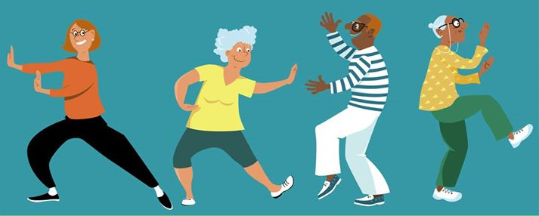

Unbalanced? Anxious? Stressed Out? In Pain?

Chi Me could be your answer!

**FREE 12 Week Chi Me Programme**

Starting Thursday 16th January 2020

10.30-11.30am

Newcastle Centre, Central Promenade

Chi Me can help improve muscular strength, balance, co-ordination, flexibility and relaxation

To book a place or find out more information please contact a member of the

Multi-Disciplinary Team in your local GP Surgery

Or

County Down Rural Community Network on 028 4461 2311